

**SRM Institute of Science and Technology**

**Department of Computer Science Engineering 18CSP103L-Seminar 1**

**Smart Home Implementation Using IoT**

Submitted by: RA1911003010894 - Pulkit Singh

Contents:

1. Acknowledgement
2. Abstract
3. Objective
4. Introduction
5. Literature Survey
6. Module Description and Implementation
7. Design
8. Challenges and Solution
9. Applications
10. Results and Discussions
11. Conclusion
12. References

Acknowledgement

Our efforts for this project would not have been possible without the kind support and help of many individuals and organizations. We would like to extend our sincere thanks to all of them.

We are highly indebted to our faculty advisor, Dr. Kalavani J, for his guidance and constant supervision as well as for providing necessary information regarding the project & also for his support in completing the project.

We would like to express our gratitude towards the HOD of Computer Science Department Dr.

B. Amutha for her kind cooperation and encouragement which helped us in completion of this project.

Our thanks and appreciations also go to our peers in developing the project and people who have willingly helped us out with their abilities.

Abstract

Home can be mechanized through the turn on or off switch utilizing these hardware gadgets. The planning of Smart Home is an application which is a mix of innovation and administrations given to the home condition with explicit capacities meant to improve the security, proﬁciency, and furthermore solace of its occupants. In the planning some portion of keen home framework normally comprises of control devices,monitoring apparatuses and programmed there are a few gadgets that can be gotten to utilizing an advanced mobile phone or PC which is associated with the Internet organize.

IOT (Internet of things) is where a few things can be associated together,sensed and furthermore remotely controlled over the system.

In the scope of this project, we have implemented smart-home using cisco packet tracer 7.2 only. However we have discussed a simple hardware model in brief too.

Objectives

* To establish an advanced newer milestone of comfort and convenience in living standards of people.
* Developing a system that will alert the user as well as their trustworthy ones about danger.
* By adding emergency triggers and music/tone recognition controllers for physically challenged people so that the beneﬁts of the system can reach a larger mass of people.
* To make the system more robust and advanced with additional functionalities.
* To have a proper intrusion detection system which can help notify about Gas leaks, short circuits, theft/robbery, Smoke and ﬁre detection which may also extinguish the ﬁre using a ﬁre sprinkler.
* Regulate the functioning of AC, Smart Window and Smart fan based on the temperature conditions.

Introduction

A smart home is a residence that uses

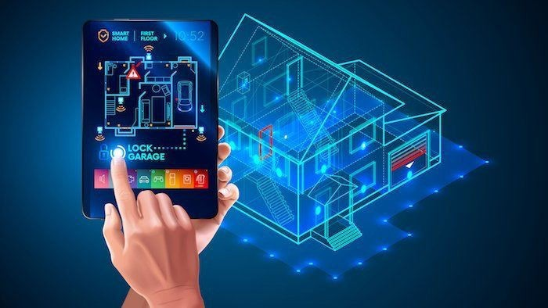

What is a Smart Home?

internet-connected devices to enable the remote monitoring and management of appliances and systems, such as lighting and heating.

Smart home technology, also often referred to as home automation or domotics., provides homeowners security, comfort, convenience and energy eﬃciency by allowing them to control smart devices, often by a smart home app on their smartphone or other networked device. A part of the internet of things

(IoT), smart home systems and devices often operate together, sharing consumer usage data among themselves and automating actions based on the homeowners' preferences.

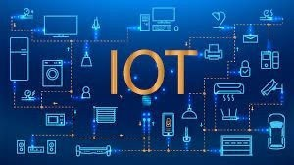

What is Internet of Things?

The internet of things (IoT) is a computing concept that describes the idea of everyday physical objects being connected to the internet and being able to identify themselves to other devices. The term is closely identiﬁed with RFID-Radio Frequency identiﬁcation, the method of communication, although it also may include other sensor technologies, wireless technologies or QR codes. The Internet of Things (IoT) is a system of interrelated computing devices, mechanical and digital machines, objects, animals or people that are provided with unique identiﬁers and the ability to transfer data over a network without requiring human-to-human or human-to-computer interaction.

Traditional ﬁelds of embedded systems, wireless sensor networks, control systems, automation and others all contribute to enabling the Internet of things.

Cisco Packet Tracer

**Cisco Packet Tracer** as the name suggests, is a tool built by Cisco. This tool provides a network simulation to practice simple and complex networks.

**The Key Features of CISCO Packet tracer that made us choose it as a software are:**

* Unlimited devices
* E-learning
* Customize single/multi user activities
* Interactive Environment
* Visualizing Networks
* Real-time mode and Simulation mode
* Self-paced
* Supports majority of networking protocols
* International language support
* Cross platform compatibility

Literature Survey

|  |  |
| --- | --- |
| Paper 1:*Smart Home using Internet of Things (IoT) R. Chittibabu, K. Kranthi Kumar, K.Vikas, G* | *Mahesh* |
| *Reddy ISSN: 2278-3075, Volume-8, Issue-6S3, April 2019*  Problems dealt in the paper:  For accomplishing domestic structure the system needs to provide a patron inviting interface at the host include, all collectively that the signs and symptoms are dependably fundamentally setup, watched.  Proposed Methodology:  To reduce the inadequacies of every gadget, this mission organizes locally and remotely managed systems with the usage of Cloud information make.  Limitations:  Whilst IoT is hooked up with sensors and actuators, the improvement modiﬁcations into an occasion of the all of the extra clearing elegance of computerized bodily systems. | |

Paper 2: *IoT Device Management Framework for Smart Home Scenarios Thinagaran Perumal1 , Soumya Kanti Datta2 , Christian Bonnet2 1 Universiti Putra Malaysia, Malaysia.*

Problems dealt in the paper:

Requirements for IoT device management in smart home scenarios and provide a bespoke framework to manage them in a federated manner. The rest of the paper is organized as follows.

Proposed methodology:

The framework can be composed of three layers vis-a-vis proxy layer,device management layer and service enablement layer.

Limitations:

Smart home scenarios are normally governed by data diversity, self-conﬁguration management, managing legacy devices as well as access control mechanism for home dwellers. These factors increase the challenges for deploying IoT ecosystem.

Paper 3: *Comfy Smart Home using IoT Shivani Jadon1 , Arnav Choudhary1 , Himanshu Saini1 , Utkarsh Dua1 , Nikhil Sharma1 , Ila Kaushik*

Problems dealt in the paper:

Development of home automation system to integrate various technologies and sub systems on a single platform and to control the system from a user interface designed for a mobile phone application, or a Web interface.

Proposed Methodology:

All these appliances will be connected to a local Wi-Fi using a local server. The automation system will be facilitating user to switch on/off home devices directly with mobile phone acting just like a remote control.

Limitations:

The threats due to web attacks exists and the Wi-Fi needs to be secured from unauthorised or external access.

Module Description and Implementation

Software Implementation:In this project, we have demonstrated smart home automation using Cisco packet tracer 7.2 variant which is another discharged innovation that incorporates every smart article planned for oﬃce mechanization

* + Router(1941)
  + Cable modem
  + Home gateway
  + IOE Server
  + Central oﬃce server
  + PC
  + Fan, AC, Smart window,Home speaker
  + Siren
  + Old Car
  + Thermostat
  + Fire Sprinkler, Smoke detector

Algorithm

Step 1: Start the project.

Step 2: Open the pkt ﬁle and save the ﬁle.

Step 3: Add the required components to the work space as packet tracer simulator.

Step 4: Connect all devices in workspace Using cables.

Step 5 : Conﬁgure the device and setup internet service provider router.

Step 6: Add Home Gateway to the Network.

Step 7: Connect smart Devices to the Wireless Network.

Step 8: Add End User Device to the Network.

Step 9: Stop

Flow Chart

Start

|  |  |
| --- | --- |
|  |  |
| Add the Components | |
|  |  |
| Configure Router | |
|  |  |

The flowchart to the right explains the Algorithm.

Check for router connection

Reconfigure

No

|  |  |
| --- | --- |
|  | Yes |
| Add Home gateway | |
|  |  |
| Connect IoT Devices | |
|  |  |
| Add an End-User | |
|  |  |

Stop

Design

IoT Gateway or Framework

Smart Phone

Motion

Siren

Fire Sprinkler Smoke

Detector Thermostat

Fan

Window

SMART HOME SETUP USING CISCO PACKET TRACER

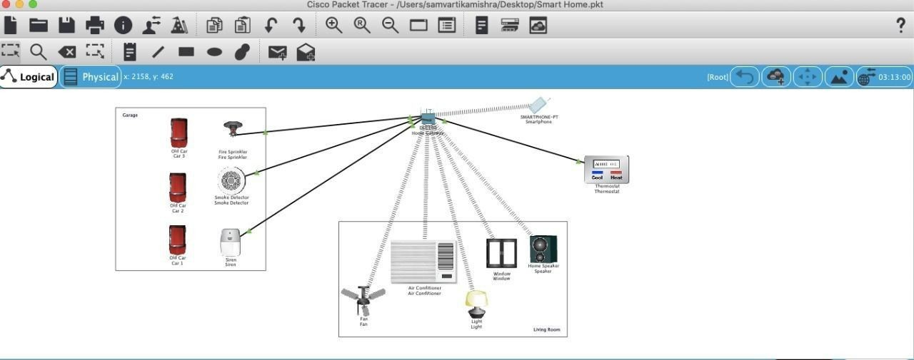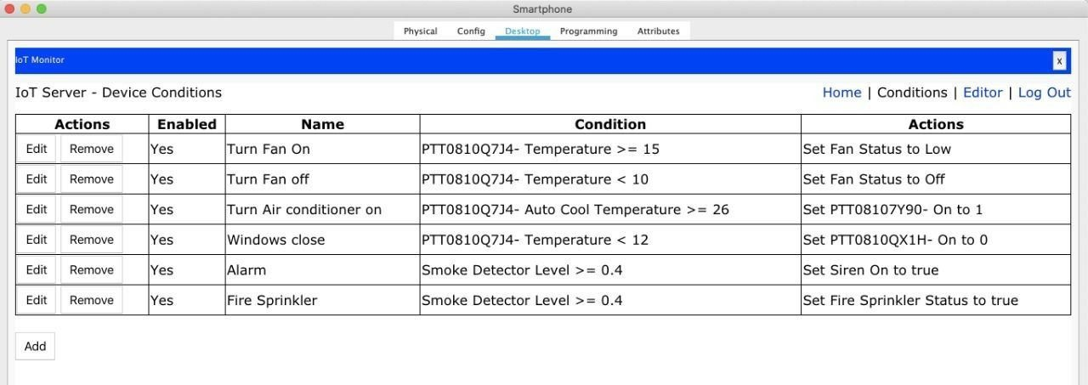

Various conditions

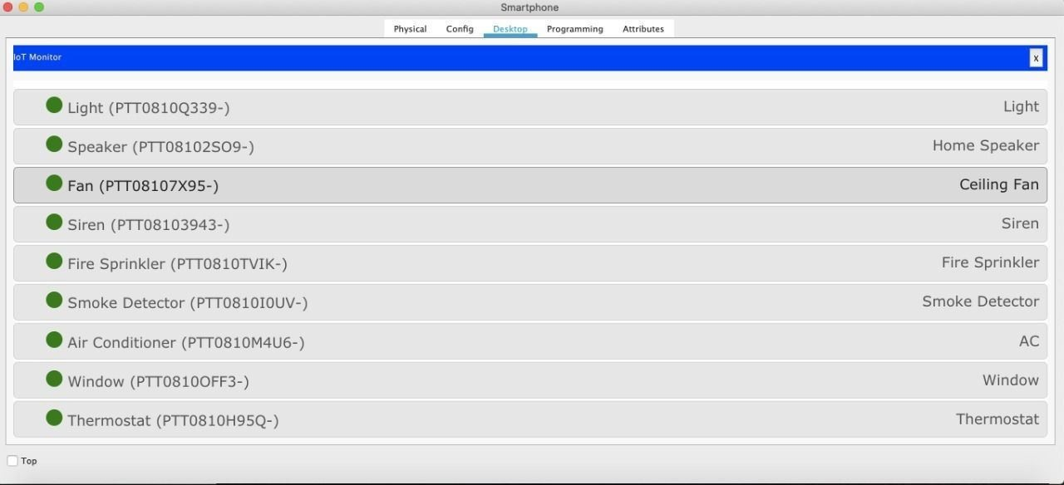

Smart devices connected to the Smartphone

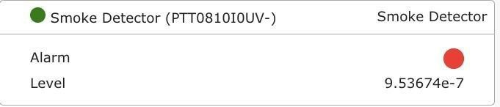

Smoke detector calculating the smoke intensity.

Currently no smoke detected

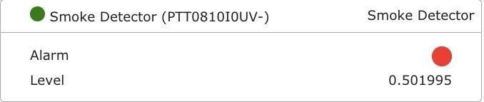

Smoke detected

The Fire Sprinkler and Siren

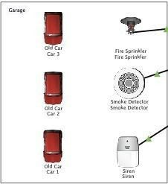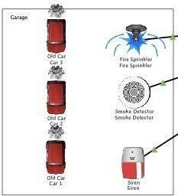

When there is no smoke, off

the fire sprinkler & Siren are

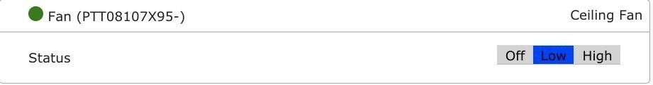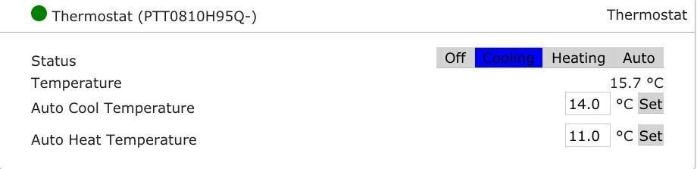

The Fan is turned on as soon as the temperature is set to 15 degrees celsius or greater

Hardware Model

Components used:

* Microcontroller(Arduino)- Acts as the home controller
* GSM Modem(SIM900A)-Used to communicate with the microcontroller from a mobile phone through SMS.
* Relay-Actuator device connected to microcontroller to turn on/off a device.
* Smart Devices- Bulb( 15W) or Ceiling Fan

Implementation:

1. The system reads the GSM modem and waits for arrival of a message from the user.
2. Then the microcontroller reads the message, compares it with the condition for controlling the equipment.
3. Accordingly, what it receives either ON or OFF. The relay is activated to turn on the bulb(Smart device), when it receives the ON message.

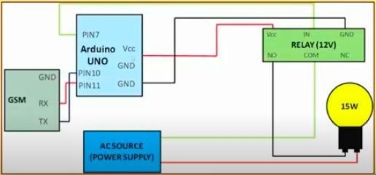

1. And the relay is activated to turn off the lamp, when it receives the OFF message.
2. The whole process continues.

Connection Diagram- Arduino UNO

Challenges and Solution

# Challenge:

The major challenge that is faced in a Android Application and Internet of Things (IOT) is in terms of the speed of controlling.

Each request takes 4 to 6 seconds to either turn ON/OFF. This is because of using open source web server.

# Solution:

If one has dedicated web server, the speed of the response could be faster and additional security features may be further implemented.

Applications

IoT is revolutionizing the way smart homes functions especially in the following areas:

* 1. Control and Monitoring
  2. Cost and Energy saving
  3. Waste Management & Health Environment
  4. Smoke Detection
  5. Temperature Monitoring
  6. Switching on and off smart devices

Results and Discussions

* IoT is a powerful technology to connect to devices.
* It’s applications are numerous.
* IoT is nothing but an Internet.
* IoT needs speciﬁc technologies and tools for its realisation.
* Low weight effective communication between sensing devices and interoperability between different communication mechanisms are critical problems in IoT.

Conclusion

This venture work is to examine the idea of the Internet of things and its pertinence in home robotization setting. Internet of things is another innovation that is utilized for the interconnection of the gadgets with the assistance of the web association.

It empowers the gadgets to detect and screen gadgets remotely. It has been told the best way to effectively manufacture a keen home that will contain advanced gadgets to thusly screen and control every action and occasions inside home utilizing IoT shrewd gadgets. So as to demonstrate the achievability of the work a reenactment instrument is utilized for planning a keen home.

References

* *Smart Home using Internet of Things (IoT) R. Chittibabu, K. Kranthi Kumar, K.Vikas, G Mahesh Reddy ISSN: 2278-3075, Volume-8, Issue-6S3, April 2019*
* *IoT Device Management Framework for Smart Home Scenarios Thinagaran Perumal1 , Soumya Kanti Datta2 , Christian Bonnet2 1 Universiti Putra Malaysia, Malaysia.*
* *Comfy Smart Home using IoT Shivani Jadon1 , Arnav Choudhary1 , Himanshu Saini1 , Utkarsh Dua1 , Nikhil Sharma1 , Ila Kaushik*
* https://[www.researchgate.net/publication/304298786_IoT_device_management_framework_for_sm](http://www.researchgate.net/publication/304298786_IoT_device_management_framework_for_sm) art_home_scenarios
* https://[www.ijitee.org/wp-content/uploads/papers/v8i6s3/F10730486S319.pdf](http://www.ijitee.org/wp-content/uploads/papers/v8i6s3/F10730486S319.pdf)
* https://[www.researchgate.net/publication/340428452_Comfy_Smart_Home_using_IoT](http://www.researchgate.net/publication/340428452_Comfy_Smart_Home_using_IoT)
* https://internetofthingsagenda.techtarget.com/deﬁnition/smart-home-or-building



**Thank You!**